**1.**

* Bar Chart
  + Uses the State column from the new DataFrame for the x axis
  + Uses the Confirmed column from the new DataFrame for the y axis
  + Uses the plotly go.bar to create a bar chart using the States and their individual confirmed cases
* Stacked Bar Chart
  + Uses Country as the new x axis values
  + Has three different traces for each unrecovered, recovered, and deaths stat to be included in a stacked bar
  + Each trace use go.bar to create their own individual bar with current numbers from chosen columns
  + All traces get put into data to consolidate them all together to create a stacked bar chart (bar chart with each x axis item having multiple different y axis values)
* Line Chart
  + User go.Scatter and sets the mode to “lines” to create a line chart rather than a normal scatter chart
  + The x axis uses the Date and the y axis uses confirmed cases
* Multi Line Chart
  + Similar to how stacked bar chart uses traces to create multiple bars we used traces for multiple lines.
  + Keeping the x axis the same (Date) and using three different values for the y axis, Death, Recovered, Unrecovered
  + Finally all traces are put into data to be used to represent the consolidated multiline chart
* Bubble Chart
  + Again go.Scatter is used but this time different arguments are passed to change how the scatter chart looks creating the bubble chart.
  + The x axis uses Recovered data and the y axis uses Unrecovered data
  + Each individual marker is placed based off of the country the data is connected to
  + Finally, the marker uses the new DataFrame “Confirmed” values to set the size and color of the bubbles
* Heat Map
  + Using day of the week as the x axis and the week of the month for the y axis
  + The z axis which creates the colors for the heat map comes from the information in the Recovered data

2. 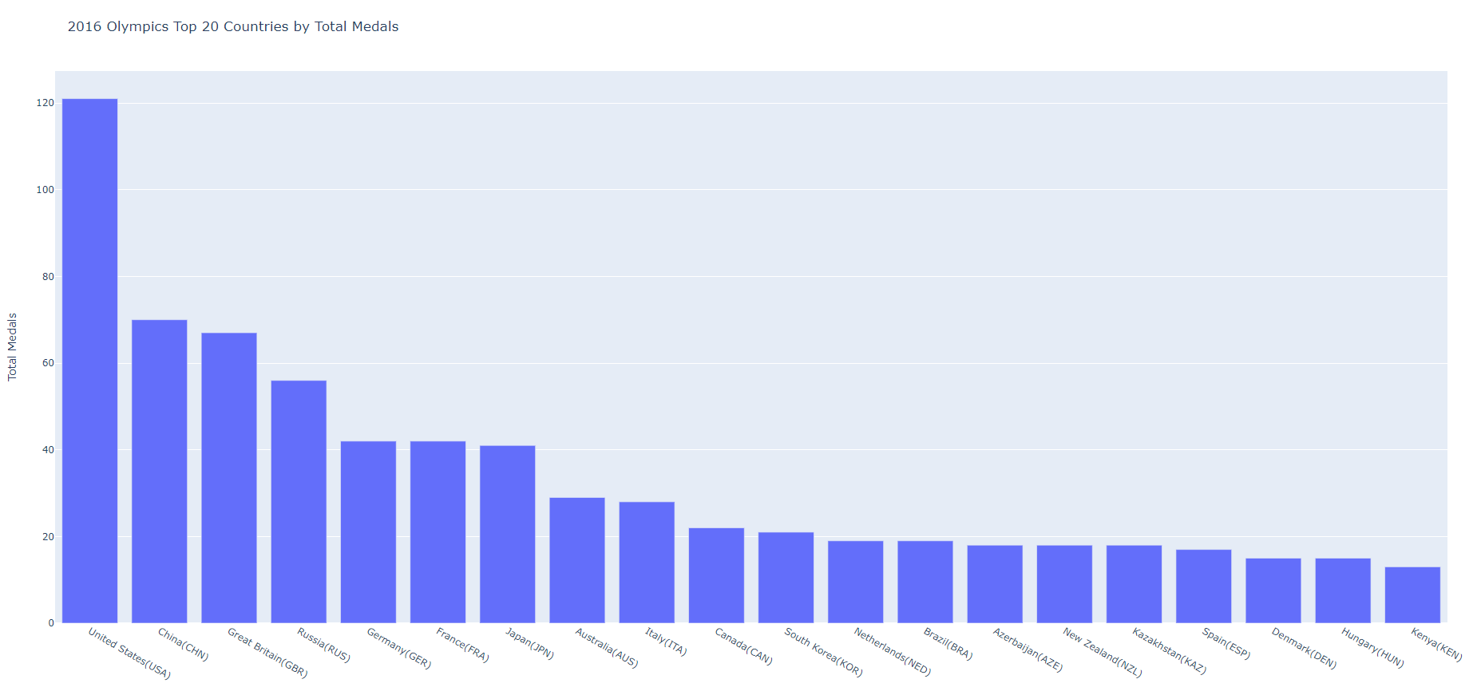

3. 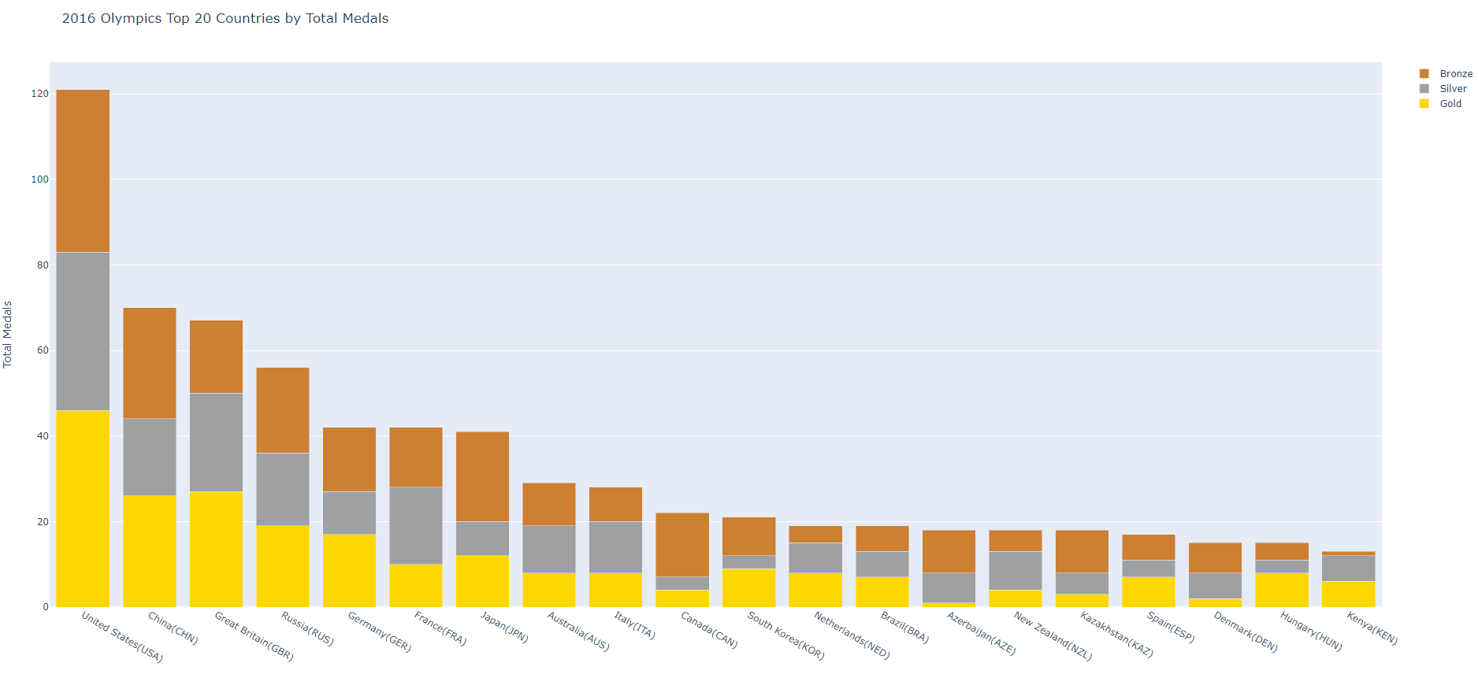

4. 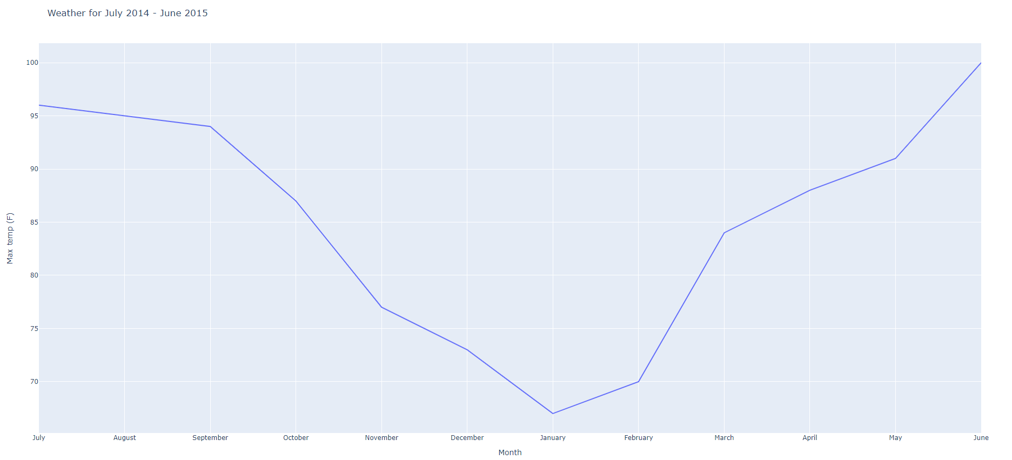

5.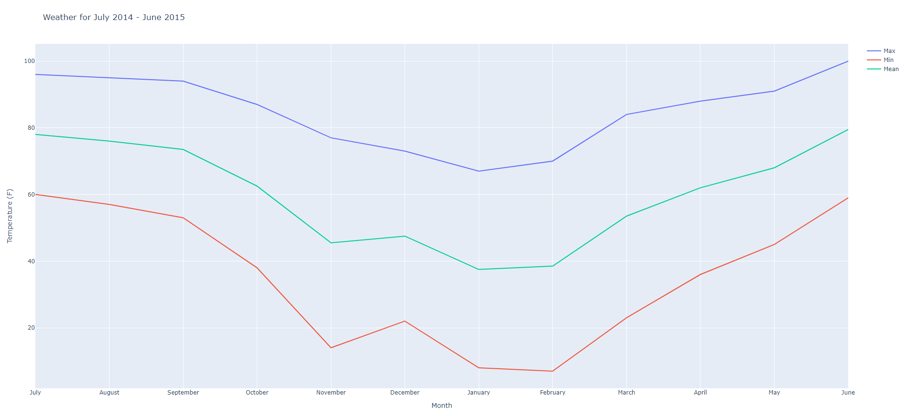

6. 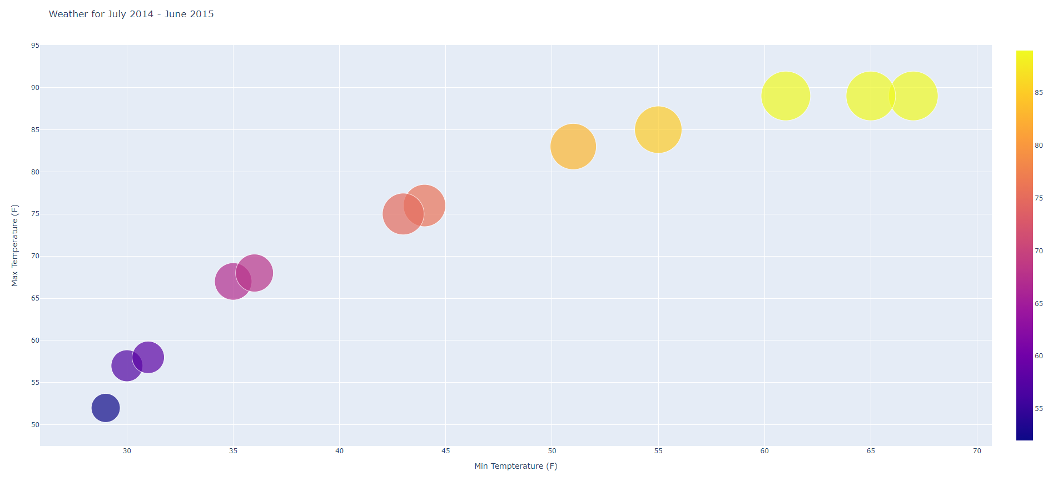

7. 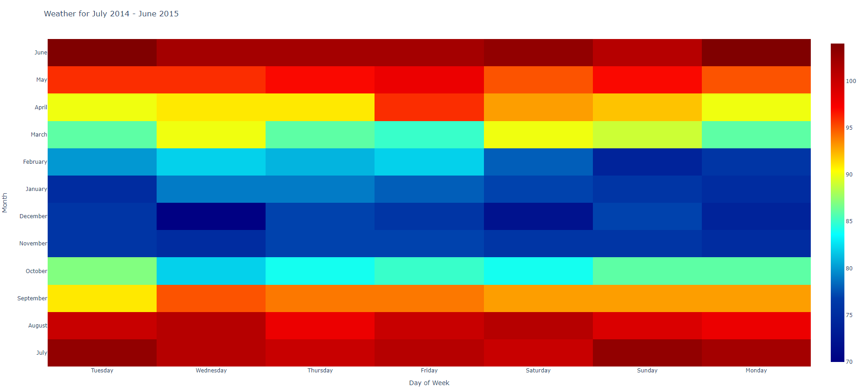

8. Each graph came with it’s own challenge as far are complexity of creation was concerned. For the bar chart and the stacked bar chart they were fairly straight forward. The information was easy to retrieve using DataFrames and easy to display using these types of charts. I think a stacked bar chart works the best to display over all medals because you can also see the breakdown of the data for each medal earned.

The line charts added a new level of difficulty since it was asking for the max temp in a month not every max temp every day of the month. The initial graph I tried included all of the max temps and the line chart didn’t look right. Eventually, I managed to sort through each individual month and pull out the row of information containing the true max temp for the each month. I did the same thing with min temp. The mean temp didn’t make sense to use the current datas actual_mean_temp since that was only mean temp by day not by month. I used the min and max from each month to add the mean into a DataFrame that could be used for the final line in the chart. Out of the two charts I think the single line chart works better than the mutliline chart because the scaling is better to see the actual change in max temp per month.

The bubble chart was fairly easy since all the necessary data was already gathered with the multi line chart. The only difference was changing the plotly instructions to create a bubble chart instead of a line chart. I think it’s a better representation of showing min and max temps together since you can see as the min temp rises the max temp generally rises as well.

Finally, the heatmap was very easy since the data was already split by day of the week in the .csv file. I am not sure how the usefulness for this information applies though because it does seem like just a huge mess of colors and information. I would understand using the heat chart for a single month but not every month in the year of recorded weather information.